# OUT RUN

# Production Stills – Captions & Credits

**OR01_campaign_parade**

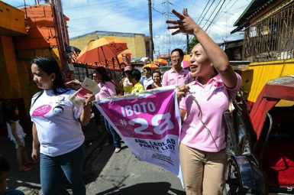

Ladlad campaigns on the streets of Manila, 2013

Photo Credit: Dondi Tawatao  
  
**OR10_Dex_Bemz_canvasing**

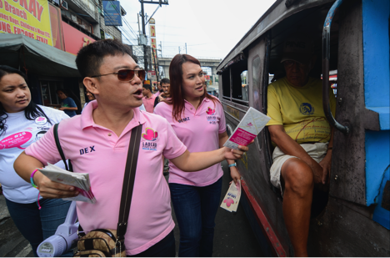

Dex Macaldo (left) and Bemz Benedito(right) hand out campaign flyers in the streets, 2013

Photo Credit: Dondi Tawatao  
  
**OR13_Santy_pride_flag**

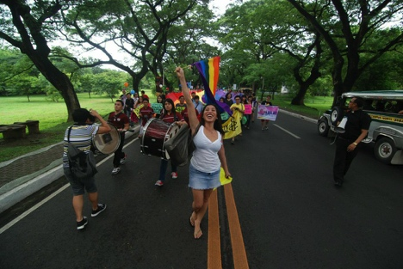

Santy Layno leads procession waving the pride flag, 2012

Photo Credit: Dondi Tawatao

**17. OR17_Bhuta_meets_with_community**

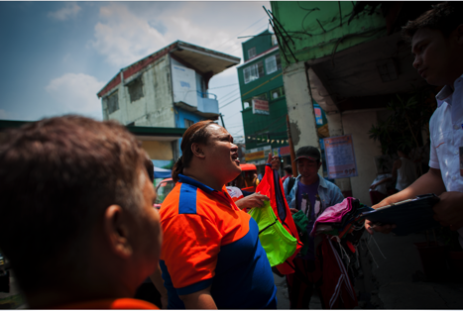

Bhuta Adelante talks with community members in her neighborhood, 2015

Photo Credit: Dondi Tawatao  
**OR18_Bhuta_with_statue**

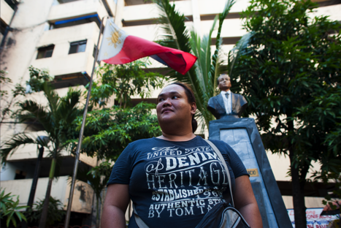

Bhuta Adelante poses in front of the Filipino flag, 2015

Photo Credit: Dondi Tawatao

**OR23_Bhuta_Raymond_Third_Force**

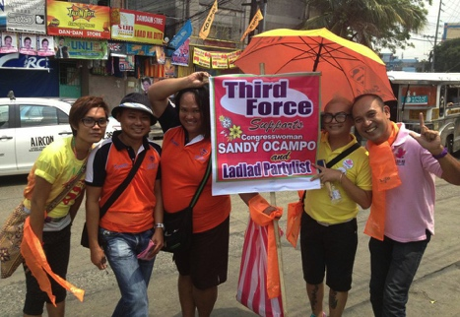

Bhuta Adelante (center) and Raymond Alikpala (right) pose with a Third Force sign, 2013

Photo Credit: Raymond Alikpala

**OR26_pride_parade_pose 2**

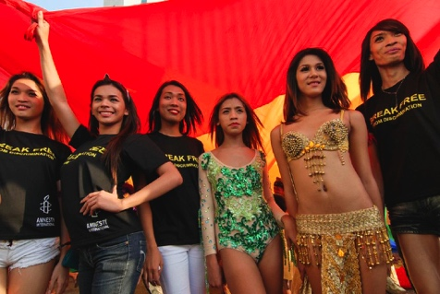

Transgender women strike a pose, 2015

Photo Credit: Dondi Tawatao

**30. OR30_angel**

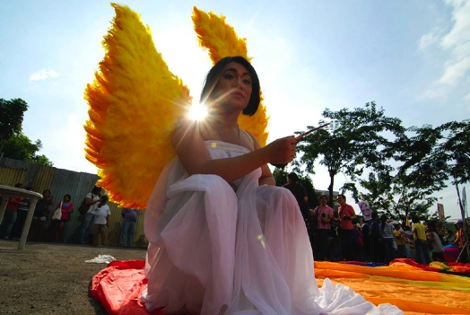

A transgender woman dressed as an angel takes a break at the Manila Pride Parade, 2012

Photo Credit: Dondi Tawatao