**LANDFILL HARMONIC**

A Symphony of the Human Spirit

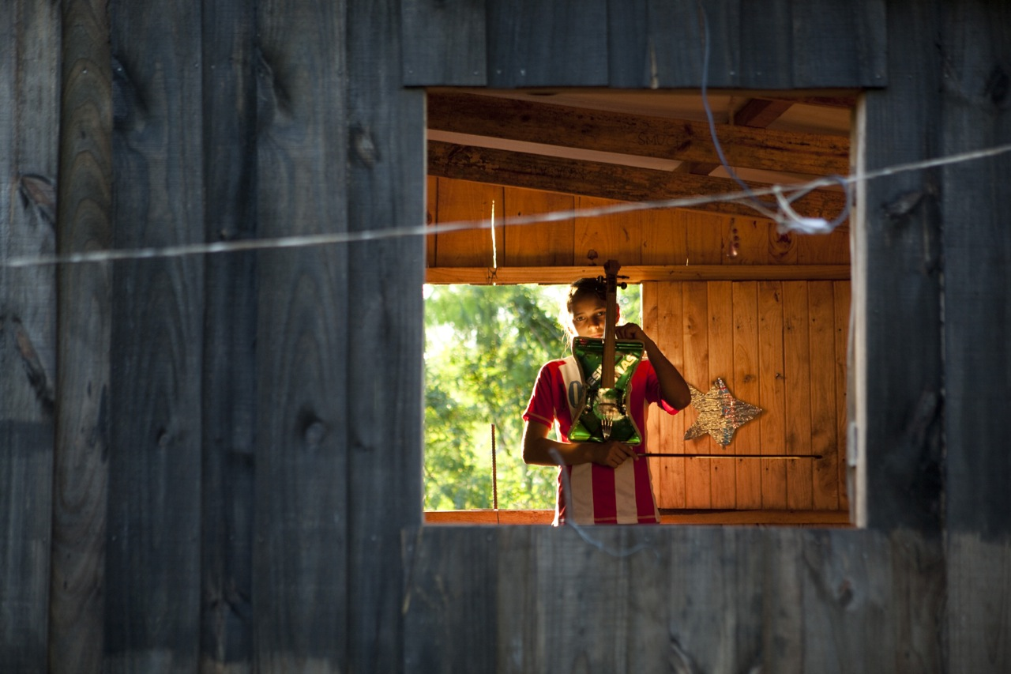

**WEBSITE:**

www.landfillharmonicmovie.com

**PHOTOS:**

https://meetaillc.box.com/s/19wzlpg6u8d6xzrbc1hw4h2ghfikh95a

**TEASER:**

https://www.youtube.com/watch?v=fXynrsrTKbI

**TRAILER:**

https://vimeo.com/122542602

**POSTER:**

[**https://meetaillc.box.com/s/azn9x9y0xv22wiyaj0hjv5f7qwro5qff**](https://meetaillc.box.com/s/azn9x9y0xv22wiyaj0hjv5f7qwro5qff)

**FISCAL SPONSOR:**

http://www.creativevisions.org/get-involved/cap/landfill-harmonic

**FACEBOOK:** <https://www.facebook.com/landfillharmonicmovie>

**TAGLINE:** A Symphony of the human spirit

**LOGLINE:**

Landfill Harmonic follows the Recycled Orchestra, a youth group who plays instruments made out of garbage. When their story goes viral, the orchestra is catapulted into global spotlight. However, when the largest flood devastates their country, they must become the source of hope for their community.

**SYNOPSIS**

Landfill Harmonic follows the Recycled Orchestra of Cateura, a Paraguayan musical group that plays instruments made entirely out of garbage. When their story goes viral, the orchestra is catapulted into the global spotlight. Under the guidance of idealistic music director Favio Chavez, the orchestra must navigate a strange new world of arenas and sold-out concerts. However, when a natural disaster strikes their country, Favio must find a way to keep the orchestra intact and provide a source of hope for their town. The film is a testament to the transformative power of music and the resilience of the human spirit.

**CREW BIOS**

**Alejandra Amarilla**(Founder & Executive Producer) Integrating philanthropy and a commitment to community service into her daily life and vision, Alejandra has aided a variety of social causes, previously putting her efforts behind Free Arts of Arizona through the documentary film Unleashing Creativity, which she co-directed. Born in Asuncion, Paraguay, her idea of making a documentary about her native country became the first step for her in creating awareness regarding children’s causes in Paraguay. Landfill Harmonic, her latest endeavor, hits close to home and has become her love project.

**Rodolfo Madero** (Executive Producer)  Rodolfo started Eureka Productions in 1993 in México. His work crossed frontiers by the end of the 90‘s when he established his production house in Phoenix, AZ. In 2004, Eureka made its debut in Adweek Magazine, being recognized as one of the 30 most important production houses in the US. As a ﬁlm composer and Executive Producer; he has taken part in full length features, short ﬁlms and documentaries.

**Belle Murphy.** (Executive Producer)  Belle is an attorney who has dedicated her career to advocating for children and giving a voice to those unable to speak for themselves. She attended the University of Washington where she earned a Bachelor’s degree in Sociology. Belle then went on to earn her Juris Doctorate from Arizona State University. Prior to her involvement in Landfill Harmonic she spent seven years with the Maricopa County Attorney’s office as a prosecutor who specialized in domestic violence, child abuse and child homicide cases. Although Belle is no longer a prosecutor she continues her focus on child advocacy and improving the lives of children by contributing to projects such as Landfill Harmonic.

**Juliana Penaranda-Loftus** (Producer/ Co-Director) Juliana Penaranda-Loftus  began her career working in production for numerous primetime television shows in Colombia. After completing her Bachelor’s degree, she moved to the United States. She then completed her Masters in film and video at American University in Washington, DC. After September 11, she directed and produced a documentary about Aid Afghanistan, an organization fighting for the right to educate women. She has also produced three feature films and established her own production company, Hidden Village Films with the purpose of producing film of social relevance. In 2012 she was one of 8 women selected by the American Film Institute for their Directing Workshop for Women. Juliana plans to pursuit the production of the political thriller film she has under development, after completing the Landfill Harmonic documentary film.

**Brad Allgood** (Director/Editor/Director of Photography) Brad is an award-winning filmmaker with a background in international development and public health. His films have taken him into the heart of the Nicaraguan rainforest, as well as to remote Caribbean islands, the sparse Kalahari desert and dense African jungles. While working for PBS Marketing and Communications, he produced national campaigns for PBS programs including the Emmy Award-winning series *Downton Abbey* and the American Experience film *Freedom Riders*. Before transitioning to filmmaking, Brad served for 3 ½ years as a Peace Corps Volunteer in Nicaragua. He holds a M.A. in Film and Video Production from American University and a B.S. in Biology and Geology from the University of Georgia.

**Graham Townsley** (Director) Graham is an emmy-nominated director of high-end documentaries for PBS, National Geographic and the Discovery channel; films such as “Becoming Human”, a 3-part series on human evolution for NOVA, “Dawn of the Maya”, “The Great Inca Rebellion”, “King Solomon’s Mines”, “Magic Mountain”, “Maya Apocalypse” and many more. He trained as an anthropologist and has a Ph.D from Cambridge University. He went on to work in ethnographic films for the BBC such as “The Shaman and his Apprentice” based on his own fieldwork with a tribe of the Peruvian Amazon and “From the Heart of the World”, a film about the Kogi Indians of the Sierra Nevada of Colombia. He lives in Washington DC.

**Jorge Maldonado**(Co-producer)  Jorge Maldonado is the Creative Director and co-founder of Hyperactive Productions, a Washington, DC based company specializing in video production, motion graphics, animation, visual effects and bilingual voice-overs. His television credits include Discovery Channel, Animal Planet, TLC, Travel Channel, PBS and The Smithsonian Channel. He has also worked on numerous projects for non-profit organizations such as Conservation International, Bill & Melinda Gates Foundation, Save The Children, and The World Bank.

**Neil Barrett**(Director of Photography) Has worked on over 30 broadcast documentary films for National Geographic, BBC, PBS, Discovery, The History Channel,  NBC,  ABC and CNN. His films have been shown at the Sundance, Tribeca, Toronto, Fullframe,  SilverDocs, Jackson Hole and Los Angeles Film Festivals.  Three of his feature documentaries—”The Woodmans” (2010), “The Other City” (2009), and “Kicking it” (2008)– have been released theatrically in the United States.

**Michael A. Levine** (Composer) was the composer for the Jerry Bruckheimer/CBS dramas Cold Case and Close To Home for which he was awarded eight ASCAP awards as well as composer for the George Lucas-produced Star Wars: Detours animated SW parody. Michael also worked on a number of Hans Zimmer scores including The Simpsons Movie, Batman: Dark Knight, and Rango. He co-produced Lorde's cover of Everybody Wants to Rule The World in Hunger Games Catching Fire, wrote the theme for Scrat the squirrel from Ice Age and the music for the classic Kit Kat Gimme A Break jingle. Michael’s concert music includes Divination by Mirrors for Saw and Strings and Concerto for Pedal Steel Guitar and Orchestra.

**FESTIVALS as of 4/15/15**

1. SXSW

Audience Award 24 Beats per Second category

2. NY International Children Film Festival

3. Environmental Film Festival in Washington DC

4. Toronto International Children Film Festival

**Upcoming Film Festivals as of 4/15/15**

- Telluride Mountain Film Festival May 24-27

- Illuminated Film Festival, Sedona, AZ May 27

- Green Festival San Francisco June 3

- Greenwich Film Festival June 4-June 7

**HIGHLIGHTS**

**-** Teaser was released in 2012 and to date over 12 million people have seen it though different social platforms.

- 60 minutes covered the story of the recycled orchestra after seeing the online teaser. The piece mentions the teaser and the documentary:

https://www.youtube.com/watch?v=5sOHfxdes1A

http://www.cbsnews.com/news/recyclers-from-trash-comes-triumph-2/