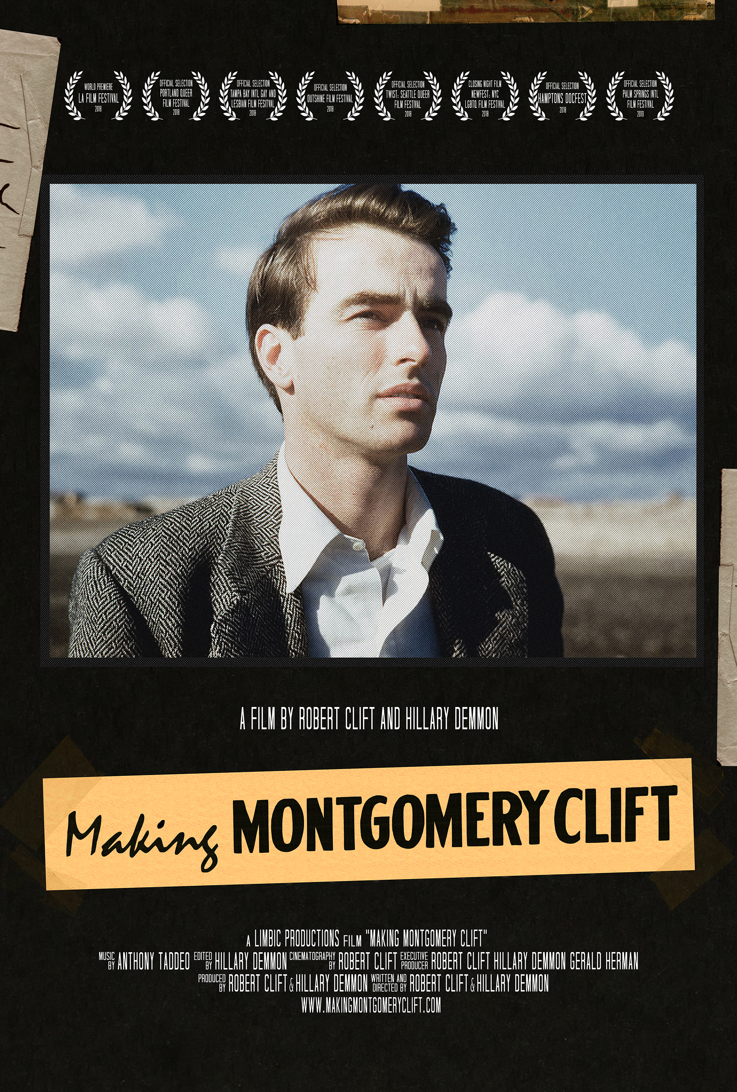

|  |
| --- |
| Festival Representative: |
| Jeffrey Winter  The Film Collaborative  137 N. Larchmont Blvd. #606  Los Angeles, CA 90004  P. 323-466-3535 / C. 818-679-8751  jeffrey@thefilmcollaborative.com |

MAKING MONTGOMERY CLIFT

TIP SHEET

Limbic Productions Presents

|  |  |
| --- | --- |
| Title | Making Montgomery Clift |
| Genre | Documentary |
| Running time | 88 minutes |
| Format | DCP/Blu-ray |
| Aspect Ratio | 16:9 (1.78) |
| Sound | Stereo Lt/Rt |
| Copyright | 2018 |
| Directors | Robert Clift, Hillary Demmon |
| Producers | Robert Clift, Hillary Demmon |
| Executive Producers | Robert Clift, Hillary Demmon, Gerald Herman |
| Cinematographer | Robert Clift |
| Editor | Hillary Demmon |
| Composer | Anthony Taddeo |
| Cast | Montgomery Clift, Brooks Clift, Ethel “Sunny” Clift, Patricia Bosworth, Jack Larson, Judy Balaban, Robert Osborne, Eleanor Clift, Lorenzo James, Tucker Tooley, Vincent Newman, Michael Easton, Mollie Gregory, Woody Clift, Eddie Clift |
| Archival Materials | Montgomery Clift, Brooks Clift |
| Website | www.facebook.com/montyfilm |

LOGLINE

Classic film star and queer icon Montgomery Clift’s legacy has long been a story of tragedy and self-destruction. But when his nephew dives into the family archives, a much more complicated picture emerges.

SHORT SYNOPSIS

Montgomery Clift was one of the most influential actors in the history of cinema, bucking traditions on and off screen, but countless biographies have reduced him to labels like “tragically self-destructive” and “tormented.” Now, nephew Robert Clift and Hillary Demmon rigorously examine the flawed narratives that have come to define Monty’s legacy. Drawing on interviews with family and loved ones and a rich collection of unreleased archival materials from Monty and his brother, Brooks Clift, this fresh portrait of the actor’s passions, contributions and commitment to living and working in his own way gives one of Hollywood’s underappreciated legends his due.

SYNOPSIS

Montgomery Clift was one of the most influential actors in the history of cinema, bucking traditions on and off screen, but countless biographies have reduced him to a tragic figure – a self-loathing, closeted alcoholic whose repressed sexuality lead him to “the slowest suicide in Hollywood history.”  Now, Clift’s youngest nephew Robert Clift and Hillary Demmon rigorously examine the flawed narratives that have come to define Monty’s legacy.

MAKING MONTGOMERY CLIFT follows Robert’s dive into a rich collection of unreleased archival materials from Monty and his brother Brooks Clift, and opens a new avenue of conversation with his loved ones to consider the Monty that they knew.

Robert’s father Brooks was greatly troubled by how his brother was remembered. Amongst his boxes of archival material are home movies, audio recordings, scrapbooks, clippings, galleys of biographies and notes all freezing in time the moments that Monty’s history was being written.  After one sensational biography was released and wounded family members, Brooks committed to collaborating with another author. But his disappointment in the process is palpable in a recording: “I realize that a great deal of what I said was just futile.”

Robert’s candid and fascinating interviews include Jack Larson, famous for his role as Jimmy Olsen on the original *Adventures of Superman* series; Lorenzo James, an uncle to Robert by way of Monty; and Monty’s close friend Judy Balaban, daughter of long-serving Paramount Pictures President Barney Balaban. Robert quickly learns that they, like his father Brooks, had serious reservations about Monty’s biographies.   Larson, for instance, relays the story of his and Monty’s first kiss, and emphasizes that Monty was not ashamed of his sexuality. Larson is bothered, too, that Monty’s sense of humor never received much attention. “He was closer to Jerry Lewis on screen than he was to Montgomery Clift on screen. You have this impression of him as serious, brooding. He was very much a clown himself,” he says.

So, Robert decides to follow the trail of breadcrumbs in both his father’s and uncle’s archives to see what might have been left out in telling Monty’s story. What emerges is a man with “an enormous internal life,” as Judy Balaban puts it.  A hardworking actor who fought the studio system for not just control over his career - refusing multi-picture contracts and demanding director and script approval - but also his life. “He wanted to be selective about roles,” Lorenzo James says, “but he also did not want to have to get married. If he signed a contract, the studios would have made him do it.” Monty had relationships of his own choosing, and made room in his life to make that possible.

This fresh portrait of the actor’s passions, contributions and commitment to living and working in his own way gives one of Hollywood’s underappreciated legends his due.

FILMMAKERS’ COMMENTS

Family Narratives

I never knew Monty. He died before I was born. My experiences of him are second-hand — talking to people he knew and cared about, sorting through family archives, and reading the numerous biographical works produced about him over the years. I learned very early that there was a deep chasm between Monty, as remembered publicly, and Monty as remembered by family and loved ones. In that chasm, there was also great deal of frustration and pain. I was too young to make sense of it all, but it stuck with me, waiting to be disentangled. This film gave me the opportunity to revisit those feelings and dig into the story behind the story. In the process, I hope that a more expansive view of my uncle’s life emerges, one that is truer to his powerful sense of integrity, creativity and intelligence. I feel like that's a valuable thing, not just for my family, but for anybody who is looking for that kind of example.

The circumstances have to be just right for any film to come together. This one, however, depended on a particular type of collaboration — one with enough intimacy to trudge through decades of family baggage and enough distance to discover how that baggage connects to broader stories of my uncle’s memory in popular culture. Directing this film with my wife Hillary allowed that to happen. It could not have been made with anyone else.

– Robert Clift

I was a junior in high school on 9/11. I can still remember a time when the fact that my grandfather was of Middle Eastern origin and that some people on that side of my family are Muslim was just sort of a piece of trivia about me. But I can distinctly remember that morning, watching the second plane crash into the towers, when one of my classmates said we should nuke the whole Middle East. I remember the escalation of rhetoric that brought us to where we are now. And people started trying to tell me who my family was, which made me so angry. Others don’t realize “those” people are my people, because I’m a white woman, and my family doesn’t fit their narrative. I’ve moved through these past 17 years acutely aware of destructive stories told by people who want more power, believed and repeated by people who are scared and/or bigoted. I’ve also learned that I have a chance that a lot of other people don’t have. I can tell a new story, and some people might actually listen.

My documentary background is largely in labor and community organizing – getting in front of members of government, community and religious leaders, workers and businesses. I do that work quietly. It’s not about me. This film my husband Robert and I have made, though, is different. His family is my family, and these people I love were hurt by an incomplete story that fixated on pathologizing Monty’s sexuality at the expense of his overall legacy. The Montgomery Clift that most people know today, if they remember him at all, isn’t somebody his family and loved ones recognized. That’s a twofold loss – first of the person himself, and then of his memory.

It has been such a beautiful, special thing to get to work with Robert on this film. The things that propel our life partnership forward carryover into our creative endeavors: mutual respect and admiration, trust and belief in each other. And for this film, which is so personal, those elements were indispensable. We knew we were on the same page as directors because we are on the same page as people. We kept asking ourselves, “Who *else* was Monty?” I so admire Robert’s philosophical tendencies toward openness, nuance and complexity, and I deeply appreciated his trust when it came to putting himself and our family in my hands as editor.

– Hillary Demmon

THE CREATIVE TEAM

|  |  |
| --- | --- |
|  | ROBERT CLIFT  DIRECTOR | PRODUCER | CINEMATOGRAPHER Robert Clift, Ph.D. is a documentarian and cinema studies scholar. He has produced and directed three documentaries, including two nationally broadcast PBS films, *Blacking Up: Hip-Hop's Remix of Race and Identity* (2010) and *Stealing Home: The Case of Contemporary Cuban Baseball* (2001). He is an Assistant Professor of Film and Media Studies at the University of Pittsburgh, where he also serves as director of the Film and Media Production Track. |

|  |  |
| --- | --- |
|  | HILLARY DEMMON  DIRECTOR | PRODUCER | EDITOR  Hillary Demmon is a Pittsburgh-based documentarian and President of Limbic Productions, Inc. She directed and edited *Road Comics: Big Work on Small Stages* (2012). In addition to documentary feature work, she provides a range of consulting and production/post-production services to commercial clients. She is passionate about advocacy and has partnered with labor unions to make films addressing human rights and worker justice. She has taught digital storytelling and media production at Georgetown University and Southern Oregon University. |